PARISH NEWS
The Deverills & Crockerton

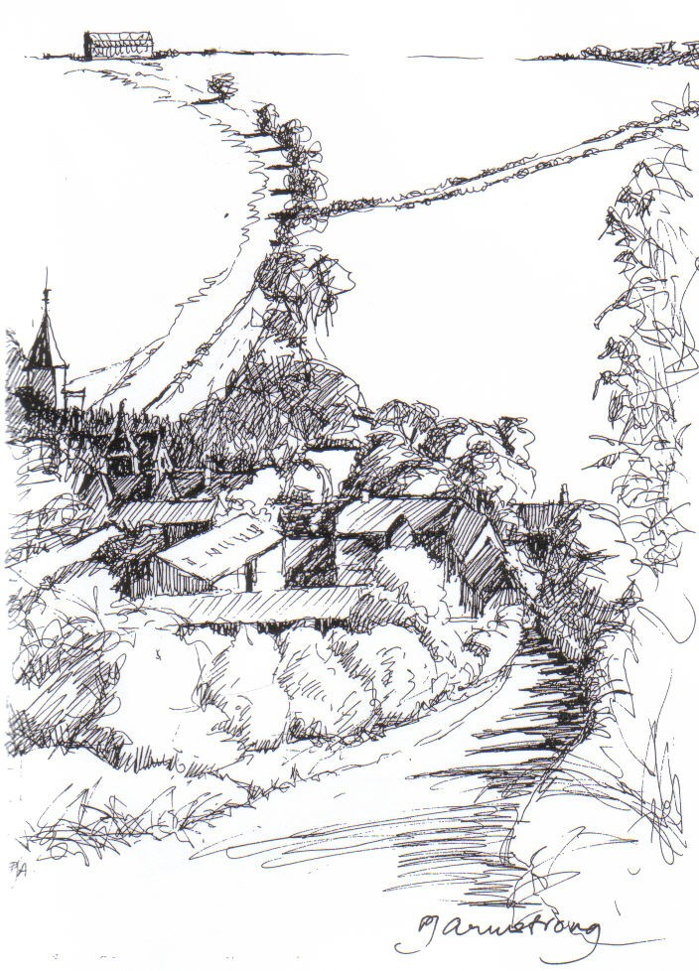

King’s Hill, Kingston Deverill
by Pat Armstrong
August 2010

Look inside for local information

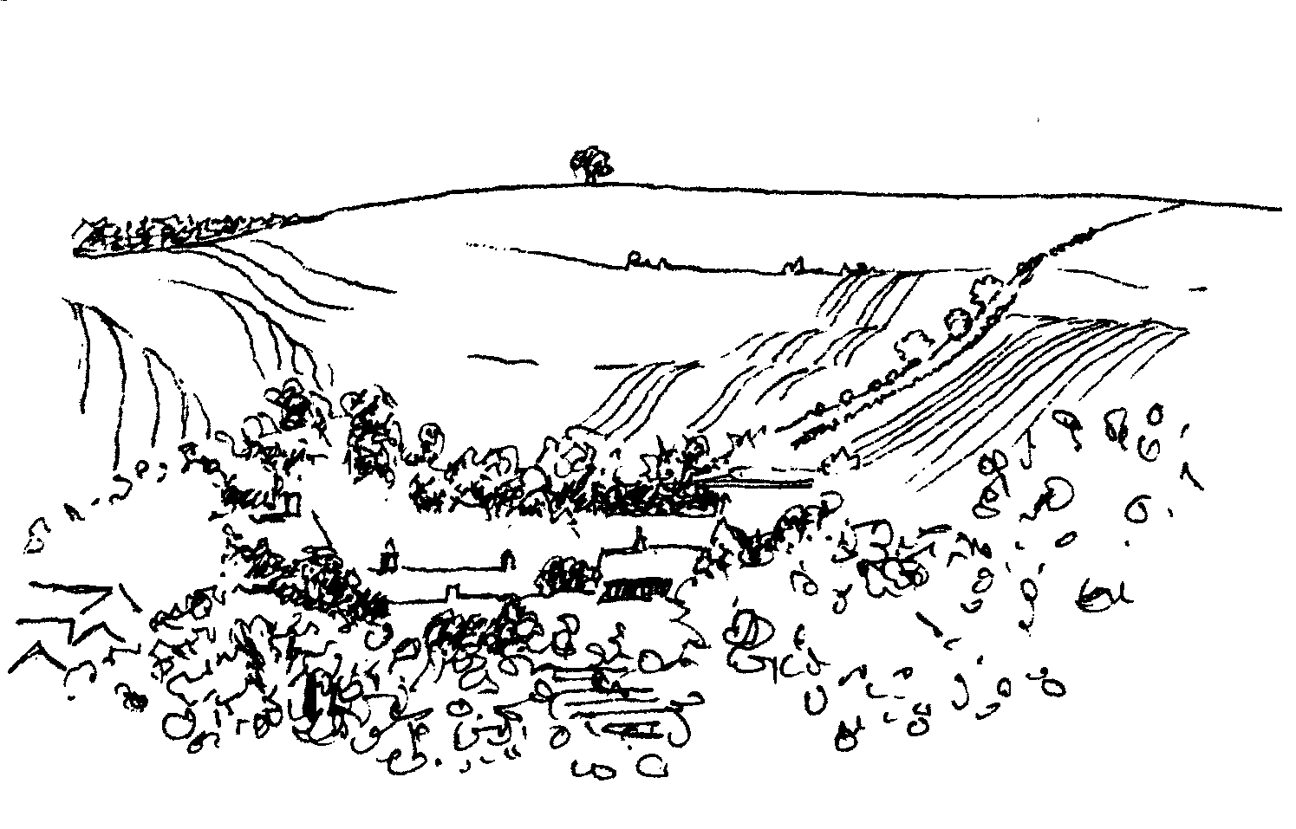
-2-

PICNIC AND SONGS OF PRAISE FOR PATRONAL FESTIVAL

Kingston Deverill Church on Sunday 15th August

Come at 4.00 pm with a picnic tea
We will enjoy some time together
in the new area of the churchyard
The service will begin at 5.30 pm

Please give suggestions for hymns to Mike (844381) or Norma (841321)

AUGUST HOLIDAY CLUB
~ three Tuesday mornings in August ~
10th at Chapmanslade School
17th at St. Margaret's Church, Corsley
24th at Chapmanslade School

Each session begins at 10.00 am
Activities finish at 12.00 noon

If you would like to, bring a contribution for a bring and share picnic lunch
Picnic lunch ~ 12.00 to 12.30
Children under 7 years to be accompanied by an adult please
For information contact: Norma Payne 841321 or Di Britten 01373 832515
Come and join in the fun!
WESSEX BLADES NETBALL CLUB
NEW SEASON - AGES 14+
ALL ABILITIES WELCOME
WEDNESDAY 11th AUGUST
AT KINGDOWN ASTRO TURF AT 7.30 pm
PLEASE RING GLENDA DICKSON 218807

Coffee, Cards and Chat
Come and enjoy looking at the new range of cards,
ribbons, wrapping paper, and other exciting items
displayed by John and Maddie Goodden
in the Upper Deverills Village Hall on Thursday 19th February
between 10.30 and 12.00 noon - everyone is welcome
Donations will be made to the hall and the church

IVY HOUSE - ST DENYS RETREAT CENTRE
Monday 9th August
House Quiet Day with Ivy House Team
Wednesday 25th August
Quiet Garden Day
For bookings & information please ring 214824

-3-

Rector writes:
I am always fascinated by the ways in which conversations have the capacity to challenge how and what we think. Just recently I have been privileged to hear a number of very special stories. While it would be inappropriate to share any of the details, I have been able to reflect on the fact that such stories focus the mind on what is truly important in our lives.
One of my reflections has been concerned with the apparent gulf between national and local organisations. What goes on nationally often seems remote until it impacts on us in more direct ways. Take the Health Service as an example. We hear and read details about changes in structure, leadership and funding. Many questions are asked about equal access to resources and other aspects of health care provision. It all seems far removed. Until that is, we or someone we care about, needs urgent medical help. Then the local becomes really important! The things I have heard recently encourage me greatly. Without exception, the quality of care has been the subject of praise. Expertise and skill have brought hope in situations, where at first sight it must have seemed absent.
I am left wondering about how the church is perceived, and especially about differences between perceptions of the national and local church. For me, at the moment, this question has been highlighted by the debates in General Synod surrounding the consecration of women as bishops. Comments locally (or perhaps I should say parochially) suggest less anxiety about the prospect than has been reflected in national debate. So is the gulf real or imagined? I am not sure it is possible to decide definitively. What I am sure about is that this matter will be the subject of future conversation and some decision taking at Deanery and Parish level.
Without doubt, there have been compromises, and some of these have cost people dear. The situation is summed up by the comments made by the Chair of WATCH (Women and the Church). “Synod’s decision gives the Church a powerful mandate to move forward enthusiastically, welcoming the ministry of women at all levels within the Church, whilst making space for those who are opposed, to stay within our body.” Hopefully as the discussion moves to the Dioceses, expertise and skill, listening and prayer, will bring hope to all that a constructive and creative way will be found to hold differing opinions together for the sake of the unity and mission of the Church, both national and local!
Norma Payne

Back to church Sunday
26th September
Come and join us
You will be very welcome at our services
Longbridge 10.30 am
Horningsham 11.15 am
Kingston 6.00 pm

-4-


Music in the Deverills Friday 10th September 8.00 pm
4+1 Jazz band (New to the Deverills)
St Michael’s Church, Brixton Deverill
Tickets £10 (inc. glass of wine)
Pre - concert supper 6.30 pm
Manor House Brixton by kind permission of Johnny & Pony Burridge
Tickets £10 (inc. glass of wine) call 840877
Cheques payable: PCC Deverills & Horningsham,
(profits Deverill Churches Fabric Fund)

SATURDAY 11TH SEPTEMBER
SUPPORT
THE WILTSHIRE
HISTORIC CHURCHES TRUST
TO TAKE PART
PLEASE CONTACT
JUDY MUNRO 844385

MacMillan Cancer Support
World’s Biggest Coffee Morning
Friday 24th September 10.00 am – 12.00 noon
Come and support us at Lakeside Garden Centre
Cakes, Raffle, Tombola etc
Donations for stalls gratefully received
Further information from Janet Budgen 218203

Salisbury Theatre Club Trips
Monday 13th September
A Voyage Round My Father
by John Mortimer
The cost is £19.00: theatre seat £14.00 (please note change) coach trip £5.00
Please book early to ensure tickets, payment in advance to Mary Stewart Cox
Tel 840877 at Longmead, Brixton Deverill, Warminster BA12 7EJ
Coach leaves Kingston Church 6.10 pm and collects through the Deverills
Performances begin at 7.30 pm

-5-

Save the Children
Cream teas and garden open in aid of Save the Children
This will be held at Mill Farm, Hill Deverill on Sunday 29th August from 3.00 pm - 6.00 pm (and on the last Sunday of the following month). There will be cakes and plants for sale as well as other interesting items. Come and enjoy a relaxing afternoon in the barn or garden.
Anne Hurd
Deverill Valley & Crockerton Women's Institute
Our meeting this month will be on Monday 9th August at 7.30 at Longbridge Deverill Village Hall and Melanie Jezzard will speak and answer questions on ‘Safety in the home’. This will be followed by tea, biscuits and a raffle. If you would like to know more about the WI in the Deverill Valley please contact Julie Wallder on 213142. You will be very welcome to join our meeting.
Deverill Valley & Crockerton WI celebrates 90 years of WIs in the Deverill Valley this year. Were you, your Mother, Aunt or Granny ever a local WI member? We are planning an exhibition in November 2010 to show achievements and community involvement of past members during nine decades of great change. If you know the whereabouts of items like photos, certificates, craftwork, news cuttings that we may borrow, or can tell us stories about WI social activities, we would love to hear from you. Please phone Jill 840209
The Deverills Cricket Club
Home matches take place on the cricket ground next to the Upper Deverills Village Hall starting from 2.00 or 2.30 pm, please do come along to watch and support us. The home fixtures are on:
1st, 22nd & 30th August, 12th September
If you would like to join the club and require further information please do call Peter Child 01963 34593 or Jamie Fagan 844123/ 07796 698180.

-6-

Longbridge Deverill Village Hall
A thoroughly enjoyable evening was had in the village hall at Longbridge on 17th July when several teams were formed to take part in the Quiz Night. A big thank you to Guy Ratcliffe for setting and asking the questions and to members of the committee who organised the event and ordered the fish and chips. Congratulations to the winning team and commiserations to the winners of the wooden spoons! Thank you to everyone who came and joined in and made it all great fun.
Pat Wood
Upper Deverills Village Hall
The Duck Race took place on Saturday 3rd July and we were blessed with a lovely sunny evening. The village hall committee wish to thank everyone who came along and purchased a duck. 136 ducks were sold to provide a boost to the hall funds. Great fun was had by all who watched the race and stayed for the barbeque afterwards. Thanks to Carol Fear for judging the best decorated duck from 18 entries. The chosen winner turned out to be an adult, Sophie Cousens, who generously relinquished the prize to a younger Sophie Lawson whose duck was judged the runner up. Thanks to Fraser Wilson who started the race. Alan Carpenter won the adult race. Alex Lee won the children’s race. Thanks to Ian Beloe for marshalling the ducks and to Jack May for a great barbeque. Also thanks to the Bush family, Mr and Mrs Child and Nonie Camell for inviting everyone into their gardens to watch the ducks from the riverbanks. We hope to see you all again next year.
John Lee
The annual Summer Fete and Dog show was held on Saturday 17th July in sunshine, much to the relief of those who attended. Entries in the Flower Show were of a high standard and the cookery classes attracted some mouth-watering creations. The Fete was well supported by the residents of the Upper Deverills, as was the annual Duck Race on Saturday 3rd July. The money raised at both events will go towards the refurbishment of the Village Hall Kitchen. The winners of the Cups and Trophies at the Fete were:
Village Hall Cup (Flowers & Vegetables): Judy Munro
Liz Peters Cups (Arts & Crafts): Avril Cousens
WI Cup (Cookery): Claire Johnson
Molly Walker Cup: The Dufosee Family
Junior Shield: Jemima Dufosee
Dog of the Day: Freddy the Lurcher
Richard Cousens

-7-

Dr Francesca Elloway – Democratic Republic of Congo
Francesca is making full use of her study of palliative medicine by passing on her learning to the local student and trained nurses. She started in Uganda where she was using English and then translated it into French to teach locally. In both places a new concept to all. The Diocese of Aru is to have a university-level nursing college, in Aru. Francesca is hoping for assistance to build this from a Dutch organisation. A new health centre is opening two hours west of Aru. Help arrived with a surgeon coming to do surgery for women at Mahagi. Francesca was managing better with her ultra sound which alas has a mechanical problem that she is trying to mend with help by email from the makers in China! Sadly, too, one of her midwives, Mawa who has 2 girls, has terminal cancer. Please pray for her and the family and for Francesca for all the different aspects of her work and for those she works with.
Elisabeth Atkinson
Farm Walk at Kingston Deverill
We were delighted that over 100 people came to participate in the walk on a beautiful sunny day. The ‘stops’ to watch the milking and to discuss the environment, the sheep and the crops appear to have been much enjoyed. I should like to thank everyone for their much appreciated help: our staff, those at the ‘stops’, the guides and the team who produced the tea and all those delicious cakes. After a generous donation, we have now raised £944 for our charities (Help for Heroes & The Deverill Churches). Brilliant!
Alice Stratton
Parish Lunch
Sunday 11th July was a perfect summer’s day with sunshine and a little breeze. Many thanks to Mike Tulloch for offering the almost Arabic marquee with lovely floral decorations for a Parish lunch. Many thanks also to Janet and her helpers for providing us with a delicious first course followed by an equally delicious variety of puddings, and to the locals who set the tables and who washed the dishes. Fifty-seven people attended who were able to relax and enjoy good company. We were very please to make a profit of £400 for our church funds.
Elisabeth Atkinson
Musical evening for Kampala Music School
The evening, on Friday 16th July, was well attended by people from the Deverills and Nunney, and a few holiday makers! Thank you to all who came and supported this event and whose contributions raised £300 for the school.

-8-

SERVICES PARISH OF DEVERILLS & HORNINGSHAM

The Deverills & Horningsham Register
Funeral and Burial
Leslie Long at Kingston Deverill Tuesday 29th June

Service of Prayer and Dedication following a Civil Marriage
Mike and Emily Tulloch at Kingston Deverill Saturday 10th July

Marriages
Thomas Diacon and Rebecca Salmen at Horningsham Saturday 10th July
Chloe Marsh and Gareth Cole at Horningsham Saturday 31st July

Sunday Trinity 9
1st August Kingston 8.00 am Holy Communion 1662
Longbridge 10.30 am Morning Worship
Horningsham 6.30 pm Evensong
Sunday Trinity 10
8th August Kingston 10.30 am Holy Communion
Horningsham 11.15 am Holy Communion
Sunday Trinity 11
15th August Longbridge 8.00 am Holy Communion 1662
Brixton 10.30 am Holy Communion
Kingston 5.30 pm (Patronal) Songs of Praise & Picnic
Sunday Trinity 12
22nd August Longbridge 10.30 am Holy Communion
Horningsham 11.15 am Morning Prayer
Sunday Trinity 13
29th August Horningsham 10.30 am Benefice Service
Sunday Trinity 14
5th September Brixton 8.00 am Holy Communion 1662
Longbridge 10.30 am Morning Worship
Horningsham 6.30 pm Evensong

Tuesday, Wednesday, Thursday, Friday Longbridge 8.30 am Prayers
Wednesday Longbridge 10.15 am Holy Communion
Parish Prayer Group meeting - Deverills and Horningsham
Tuesday 3rd August 7.00 pm to 8.00 pm at Mary Royall’s house (840338)

-9-

SERVICES PARISH OF CORSLEY & CHAPMANSLADE
Sunday Trinity 9
1st August Corsley 9.00 am Holy Communion
Sunday Trinity 10
8th August Chapmanslade 9.00 am Holy Communion
Temple 11.00 am Morning Prayer
Sunday Trinity 11
15th August Chapmanslade 9.00 am Holy Communion
Corsley 6.00 pm Holy Communion
Sunday Trinity 12
22nd August Temple 9.00 am Holy Communion
Corsley 10.30 am Parish Service
Sunday Trinity 13
29th August Horningsham 10.30 am Benefice Service

Sunday Trinity 14
5th September Corsley 9.30 am (new time) Holy Communion

Church Cleaners for August
Kingston – Judy McCulloch & Carol Noonan
Brixton – Georgina Hammick & Julia Abraham
Longbridge - Monday 2nd August 9.30 - 10.30 am - all helpers
Church Flower Arrangers for August
 | Kingston | Brixton | Longbridge
1st August | Charlotte Williams | Mrs McDonald | Trish Birts
8th August | Charlotte Williams | Mrs Lawson | Sylvia Titt
15th August | Alexandra Blair | Mrs Lawson | Sylvia Titt
22nd August | Alexandra Blair | Mrs Greenwood | Jo Steptoe
29th August | Maddie Goodden | Mrs Greenwood | Jo Steptoe

Contact the Clergy
Please contact Norma Payne (841321) or Di Britten (01373 832515) if anyone is housebound and would like communion or a visit at home;
or if someone is ill and needs our prayers; or to discuss any church matter.
Administrator phone 215460 or email: churchofstdenys@btconnect.com

-10-

Recipes of the Month
Sponsored by Maiden Bradley Community Shop (844206)

Courgette Salad (serves 4)
4 medium sized courgettes
1 small bunch rocket
1 handful basil leaves
Parmesan shavings to garnish
5 tablespoons extra virgin olive oil
Salt and freshly ground pepper
Method
- Using a potato peeler, peel thin ribbon like strips from each courgette until you reach the centre core.
- Add to courgettes, 4 tablespoons of olive oil, mix together carefully with fork, cover and leave to marinade for an hour.
- Before serving, add rocket and basil roughly chopped, add salt and black pepper, extra (5th) tablespoon of olive oil.
- Garnish with Parmesan shavings.

Stuffed Courgette Flowers (serves 4)
12 courgette flowers
100 gms of full fat cream cheese
1 handful of chives, chopped
Extra virgin olive oil for brushing
Salt and black pepper
Method
- Pre-heat oven to 150ºC Gas mark 5.
- Carefully wash courgette flowers inside and remove stamens.
- Mix the cheese with chives, salt and pepper, spoon inside the courgette flowers, place on a baking tray lined with greaseproof paper.
- Brush with oil, sprinkle with salt.
- Place in oven, cook for 15 minutes.
- Allow to cool a little, before serving.

-11-

Where have you been?
This month I am indebted to two contributors: Judith Mirzoeff of Kingston Deverill for the piece below on the farm shop and Jo Nelson for her recommendation of an Italian restaurant in Salisbury.
Wylye valley vineyard farm shop
There has been a vineyard on the A350 near Crockerton since Paul Dale put in the vines in 1989. The farm shop he built on the site is much more recent, opening in December 2008. We have found it a useful place for good local produce. Fresh vegetables come straight from the growers; there is good range of cheese from Dorset and Somerset as well as Wiltshire, and Sandridge bacon and sausages. Salad comes from Folly Farm; there is Hurd’s watercress, Wiltshire Tracklements, Taylor’s bread and the Olives et Al range, and the products of the Wiltshire smokehouse at Sutton Veny. Basics like milk, eggs, tea, coffee are also stocked, and a new range of pies.
Those who have not yet tried the farm produce may know the Vineyard for its Wessex Brewery beers, including Deverill’s Advocate and Sheppey’s cider. There is usually a guest beer too. Plastic containers are supplied or bring your own. What, you may ask, has happened to the wine, which Paul started making in 1996? The last couple of years have not produced good grapes because of the weather, but this year the vines are in excellent shape and Paul is hoping for a vintage. The white wines are all named after fishing flies: Coachman is dry, Teal and Green less so, and Watson’s Fancy is sweeter. So you can save drink miles, as well as food miles, by shopping here.
Da Vinci Italian Restaurant, 68 Castle Street, Salisbury (01722 328402) www.davinciofsalisbury.co.uk
I have found it difficult to find a pleasant place to eat in Salisbury at lunchtime - unless you want a pizza! - but have recently discovered the Da Vinci Italian restaurant in Castle Street. It has a typical Italian menu, (although we have had an ostrich steak which does not seem very Italian!) a good choice of well cooked food, helpful waiters, linen napkins and a special lunchtime menu of about 12 items for £7.00 per person. It is definitely worth a visit at lunchtime or evenings.
After receiving Jo’s recommendation I decided to try this out with a friend and I have to say that we were not disappointed. There was a choice of about 10 different dishes and when the chef heard me discussing my problems with dairy he came out of the kitchen and offered to do any dish on the menu which he would adapt to exclude cows’ milk – service indeed! The reason he can do this, of course, is because every dish is cooked fresh to order which means it is not immediate, but we did not wait long and it was well worth it. I had a delicious vegetable risotto and my friend had linguine which she said was excellent. The £6.95 a head also includes a drink – good value and a pleasant place to eat (and charming Italian waiting staff).
If you have somewhere you would like to recommend, please send your comments and suggestions to me by email at farthings.kd@btinternet.com or through my letter box at Farthings, Kingston Deverill.
Trish Shuler

-12-

Upper Deverill Parish Council
Waste Consultation
Wiltshire Council is reviewing the way it manages waste across the County and they are keen to hear your views regarding the proposal to harmonise services by providing:
A kerbside collection of plastic bottles and cardboard every 2 weeks.
A kerbside black box collection for glass, papers, cans, foil and textiles every 2 weeks.
A non chargeable optional kerbside collection of garden waste every 2 weeks.
A collection of left-over waste every 2 weeks.
You can post your comments online at www.wiltshire.gov.uk/waste. Alternatively, a leaflet explaining the proposal is available at libraries, leisure centres, contact points, council offices and the parish clerk. Please complete the questionnaire attached to it. Please return all comments by Friday 20th August.
Transport
The consultation on the Local Transport Plan draft Parking Strategy is now available for viewing at http://consult.wiltshire.gov.uk/portal. Wiltshire Council would welcome your comments on this document - there is the opportunity to respond to specific questions and make general comments at a number of points in the document. The consultation will run until 5.00 pm on Friday 3rd September.
Don't forget that the next Parish Council meeting is on Wednesday 15th September 6.30 pm at Upper Deverills Hall. Anyone is welcome to attend.
Sarah Jeffries Clerk
Wasps
Disturbing a wasp nest can be dangerous, particularly in a confined area such as a loft space. Pest control officer at Wiltshire council, Simon Cleaver, advises that it is only necessary to treat wasp nests which pose a particular danger to yourself or you family. The simple advice offered is not to try to deal with them yourself. If a nest is near a window or a door, or the insects regularly find their way into your house, it is best to get a qualified pest control officer to deal with the problem. There is usually no need to remove a nest following treatment. Although wasps are generally disliked because of their sting, most species will sting only when the wasp is aroused or frightened. You can find out more by visiting: www.wiltshire.gov.uk/publicprotection.

-13-

Nature Notes
Yesterday, 15th July, was St Swithin’s Day and according to the saying, as we had rain, we are due for another 40 days and nights of the same! We could probably do with it as rain has been sadly lacking. The ground has become very hard and the soil so dry. Grass is desperately short so hopefully this bit of rain will encourage some growth. Birds and animals alike must be having real problems finding enough to eat and drink. Badgers love earthworms and these will have gone deep down into the soil out of reach. I was walking along the lane the other evening and caught sight of a badger that definitely looked in quite poor condition. We have had a mole digging under the bird bath where the ground is softer, but even then it seems to be just under the surface. At least with the hot weather we’ve been having there have been plenty of insects available.
Judging by the number of young birds we have been seeing in the garden it seems to have been a successful breeding season. Blackbirds, house sparrows, goldfinches, tree sparrows and starlings have all done well, and great and blue tits exceptionally so. I have not seen so many robins, chaffinches or greenfinches. The swallows in the garage continue to do very well and so do the house martins. I think we may have several house martin nests ready to fly; I hope they wait until this wind drops. The rain we most certainly need but we could do without the wind. I am hoping that my plants on the patio and my runner beans out on the vegetable patch manage to stand up to the battering that they are having. This is the sort of weather that brings down limbs of trees; being in full leaf they are heavy and at their most vulnerable. Our old beech trees up on the farm often succumb and it will be no surprise to see damage after the night that we have just had.
Heavy rain and wind can be devastating for crops. They get bashed down making them more difficult to combine. Once down they become more vulnerable to damage from rooks. When they get very wet the corn can sprout, wheat is the worse crop for this. Hopefully the rain will just do some good and fill the grains and the wind will dry the crop nicely and not blow it down. Rape can get in a right mess in strong winds and end up a complete tangle looking like an angry sea!
Last year we had 3 wild bee colonies in the beeches. We lost one when the limb housing it fell down back in the autumn. One colony has definitely survived. It is deep in the main trunk of the tree so is nicely protected from the elements. The other colony was up high in one of the narrow limbs of a tree and I have my doubts as to whether it is still there. I did see some activity earlier in the year but none since. Perhaps they have moved to a safer site. I was suspicious that a jackdaw had moved into the hole. We think jackdaws may be the culprit for predating the little owls that had nested up in the beeches. The chicks certainly hatched but then it all went quiet. I know jackdaws were nesting in the same tree very close to the little owls. Hopefully the owls will return and try again next year. I am told that they are loyal to a nesting site.
Jane Trollope (written on 16th July)

-14-

LOCAL COUNCILS, SOCIETIES, GROUPS etc.
Longbridge Deverill and Crockerton Parish Council
Karen Manfield 215285 (Chair) Peter Whithey 840347 (Vice Chair)
Helen Few 840119 (Clerk) Thomas Minter 216909
Bill Hurd 840023 Elaine Pidgeon 212878
Julian Algar 840816 Graham Read 840296
Brian Marshall 214789
Upper Deverills Parish Council
Lady Felicity Wheeler 844683 (Chair) Ranald Blue 841374
Sarah Jeffries 213436 (Clerk) Patricia Shuler 844291
Sarah Fagan 844123 Robin Greenwood 840743
Wiltshire Councillor
Fleur de Rhé Philipe 213193

Wiltshire Council 0300 456 0100

Longbridge Deverill Village Hall Committee
Pat Wood 840535 (Chair) Julie Read 840655 (Secretary) Sylvia Titt 214825 (Caretaker)

Upper Deverills Village Hall
Richard Cousens 844970 (Chair)
Mandy Martyn 844320 (Secretary) John Lea 844325 (Hall bookings)

Crockerton Millennium Committee
Marion Thomas 213739 (Chair)

Pre-School Children and Parents ‘Thursday Group’
Sylvia Titt 214825 Pat Wood 840535

Deverill Valley & Crockerton W I
Ruth Sutton (President) Julie Wallder 213142 (Secretary)

Sir James Thynne Almshouse
Mrs Sue Jackson 840322 (Steward)

Deverills Cricket Club
Jamie Fagan 844123 Peter Child 01963 34593

Wylye Valley Tennis Club
Colin Singer 213696

Wylye Valley Flower Club
Mrs Hazel Yate 215617 (President) Mrs S Scott 216584 (Programme Secretary)

Wiltshire Wildlife Trust
Elm Tree Court, Long Street, Devizes SN10 1NJ www.wiltshirewildlife.org

Rural Community Beat Manager - Police Community Support Officers
PC Vicky Pegrum - PCSOs Ian Owen & Caroline Wright - 0845 408 7000

Hospital Transport Link Scheme 211655

-15-

F O R T H C O M I N G E V E N T S
Forthcoming Events
- Scottish Dancing Monday Evenings Aline Fry (841054)
- Tennis Coaching 9.30 am Tuesday Mornings Judith Hirons (845255)
- Bell Ringing at Longbridge Wednesdays 7.30 pm Richard Munro (844385)
- Hearing Loss Lip-reading Wednesdays Margaret Head (213259)
- Pre-school & Parents Group Thursdays 10.00 - 11.30 am See p14
- Deverills Chamber Choir Fridays 7.30 pm Claire Johnson (07967 609520)
- Deverills Cricket Club Sundays 1st, 22nd & Monday 30th August See p5
- Parish Prayer Group Tuesday 3rd August See p8
- WI Meeting Monday 9th August See p5
- August Holiday Club Tuesdays 10th, 17th, 24th August See p2
- Wylye Valley Flower Club visit to Aldsworth House Tuesday 10th August See p14
- Wessex Blades Netball Club Wednesday 11th August See p2
- Ivy House Quiet Days Monday 9th & Wednesday 25th August See p2
- Song of Praise Sunday 15th August See p2
- Save the Children Teas Sunday 29th August See p5
- Longbridge & Crockerton Parish Council meeting 7.30 pm
Monday 6th September at Longbridge Village Hall See p14
- 4+1 Jazz Band Friday 10th September See p4
- Ride and Stride Saturday 11th September See p4
- Deverills Cricket Club Sunday 12th September See p5
- Salisbury Theatre Club Monday 13th September See p4
- Upper Deverills Parish Council meeting 6.30 pm Wednesday 15th September at Upper Deverills Village Hall See p12/14
- Macmillan Cancer Support Coffee Morning Friday 24th September See p4
- Back to Church Sunday 26th September See p3
- Save the Children Teas Sunday 26th September See p5

F O R T H C O M I N G E V E N T S
16-
PARISH OF DEVERILLS AND HORNINGSHAM
Contact the Editor and the Website

Parish News Editor: Judy Munro 844385
Contributions for the Parish News through my letterbox or
by post to Whitepits Lodge, Kingston Deverill, Warminster,
BA12 7HD or by Email: judymunro@tiscali.co.uk Thank you
Please remember the deadline is the 15th of every month

Website: www.deverills.org.uk
Email address: info@deverills.org.uk
Website manager: Kate Wilkinson 844998
Contents: Parish News with church services, Parish Register, Events,
Local news plus pictures and other information
Churches
SS Peter & Paul the Apostles Longbridge Deverill
St Michael the Archangel Brixton Deverill
St Mary the Virgin Kingston Deverill
St John the Baptist Horningsham
Rector
Rev Norma Payne, 6 Homefields, Longbridge Deverill 841321
Clergy
Rev Diana Britten, 69 Lane End, Corsley 01373 832515
Licensed Lay Ministers
Mr John Budgen 218203
Col Robin Chappell 212153
Churchwardens
Mrs Elisabeth Atkinson (Longbridge Deverill) 212129
Mrs Mary Stewart Cox (Brixton Deverill) 840877
Major Mike Tulloch (Kingston Deverill) 844381
Mr Tim Moore (Horningsham) 844336
PCC Treasurer Mr David Stratton 844549
PCC Secretary Mr Nigel Poole 840902
Church Electoral Roll Officer Major Mike Tulloch 844381
Parish News Editor Mrs Judy Munro 844385
Organist Mr John Budgen 218203
Bell Tower Captain - Longbridge Mr Steven Young 212796
Caretaker - Longbridge Church Mrs Sylvia Titt 214825
Office Administrator Mr Dick Collins 215460
(Mon -Thurs 10.00 - 12.00) St Denys, Warminster

